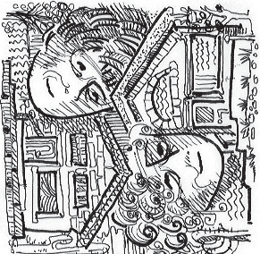
POSSSLQ

Elder Living
Outside the Box

One of the great radio poets of the 20th century was Charles Osgood. He had a daily program … in the 1970’s and
80’s in which he read his own funny poetry on a variety of current topics in the news. One day, the poem was about the POSSLQ -- that is the census bureau’s word for Person of Opposite Sex Sharing Living Quarters. Here’s the poem read by Charles Osgood.

My POSSLQ
There’s nothing that I wouldn’t do If you would be my POSSLQ. You live with me, and I with you, And you will be my POSSLQ.
I’ll be your friend and so much more; That’s what a POSSLQ is for.
And everything we will confess; Yes, even to the IRS.
Some day on what we both may earn,
Perhaps we’ll file a joint return. You’ll share my pad, my taxes, joint; You’ll share my life - up to a point!
And that you’ll be so glad to do, Because you’ll be my POSSLQ.
Charles Osgood
from Wikipedia

CONTENTS
- A HAWK’S VIEW OF POSSSLQ 1
Sharon Kha & Deborah Knox
- ODE TO A POSSSLQ 2
Sharon Kha
- EMPTINESS OR EMPTY NEST? 5
Deborah Knox
- WHAT A POSSSLQ IS FOR 8
Sharon Kha
- QUALITY OF LIFE AS A POSSSLQ 9
Deborah Knox
- WHAT MAKES IT WORK? 10
Sharon Kha & Deborah Knox
- TIPS FOR BECOMING A POSSSLQ 12
Sharon Kha
- RESOURCES 14

A HAWK’S VIEW OF POSSSLQ
Sharon Kha & Deborah Knox

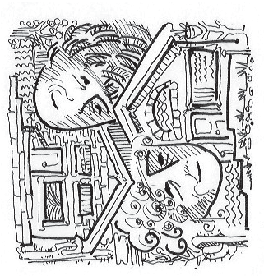If you had been a hawk circling high above Tucson, you might have found the story of how Deb Knox and Sharon Kha created their own POSSSLQ unremarkable.

A hawk can see the beginning and the end, and from its perspective the distance between them was only ten minutes as the hawk flies. They had a lot of common interests and, as it turned out, even some friends in common. But for Sharon and Deb who were seeing these same events from the viewpoint of a gecko who skitters along the ground, seeing only the patch of dirt immediately in front of its gecko nose, it was a blazing miracle that their lives intersected, let alone merged into a POSSSLQ.

It was the Census Bureau who created the category in the 1970s when they realized that the communal life established by hippies in the sixties didn’t fit into neat “single or married” boxes. So they developed a new category: Persons of the Opposite Sex Sharing Living Quarters .
Since they were not of the opposite sex, Deb and Sharon modified it to read “Persons of Similar Sensibilities Sharing Living Quarters.“ It refers to a shared housing agreement that is neither a romantic nor a business relationship but falls somewhere in between.

In some ways, they couldn’t have been more different. Sharon’s career included being a news reporter for KGUN-TV for ten years and associate vice president for institutional advancement at the University of Arizona. Deb was her own boss most of her life. She’s the author of two books, a career counselor and she teaches classes in writing (her current classes are on writing your spiritual memoirs). Sharon has one son; Deb never married and never had children. Both of them like writing and creative endeavors of all sorts; they are pacifists; Deb was raised Unitarian and now sits with Quakers; Sharon was raised Mennonite and is now a Presbyterian at a church that emphasizes social justice. All in all there are enough similarities and differences to make a really interesting life if they could just get together.

Sharon didn’t want to become a burden to her family; Deb didn’t want to be burdened with a mortgage and HOA fees plus the debt she had acquired over time. Deb was trying to sell her house; Sharon was trying to find a way to stay in hers. They didn’t know it at first but they were both in search of an elusive thing called intimacy. In the pages that follow, you will hear their story first from Sharon’s point of view, then from Deb’s and some tips and resources about how to create a POSSSLQ of your own.

ODE TO A POSSSLQ
Charles Osgood who used to host CBS Sunday Morning must have liked the word POSSSLQ. He wrote a poem about it and read it on the air when he retired.

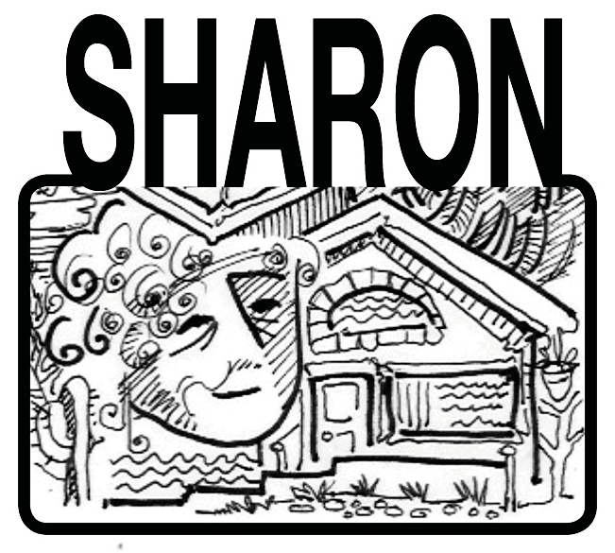“There’s nothing that I wouldn’t do If you would be my POSSLQ”
(pronounced Possle-cue)

I’m lucky, I think to myself. I found my POSSSLQ.

Not everybody thinks of me as lucky, of course. I have advanced Parkinson’s Disease, stage four kidney failure, a giant brain aneurism, and a history of pulmonary emboli. Money slithers away without my noticing. I can’t afford more caregivers. When
I heard my not-so-great diagnosis, I did a good job planning my
death. I wrote my own obit; I made a will. I pre-paid for my cremation. I picked a caterer for the reception after the memorial service. I cleaned my closets. I was ready for death, but I spent no time whatsoever to plan for life.

A near fatal fall convinced me that it was time for me to take charge of my life or I would find that events were sweeping me away. The way I saw it, I had two options: assisted living and shared housing.

I had visited 17 assisted living facilities. They were all nice, they all had nice food and there were
nice people there, and I just wasn’t ready for a lifestyle that was a symphony in beige.

Shared housing sounds mighty attractive. It addresses the needs of the gerontological set in that awkward time of life when we aren’t ready for assisted living but can’t live alone. It is the idea that two people (or more) choose to live together not because they are friends or relatives but because they have mutually beneficial needs and resources.

“I’ll find someone who would like to trade sharing my house rent free in return for cooking dinner every night,” I told myself. I was convinced that as soon as the word got out that a witty and cosmopolitan and literate woman such as myself was looking for a POSSSLQ, there would be a line of applicants outside my door, all eager to set up housekeeping with me. But how do I find the right person? Do I put an ad in the paper that says “Live Rent-free with Gullible Woman?” No, I thought. Instead, I started talking to everyone about the kind of person I was looking for. I talked incessantly to my friends at church about my plan. I talked in the coffee shop where I stop every morning. I talked about it to my friends and neighbors. Everyone knew I was looking, but when I met my POSSSLQ, Deb, it was an unplanned encounter.

I found Deb Knox by the luckiest of remote chances. I was telling my friend Beth whom I’ve known for 45 years about my search when another friend stopped by for a moment, heard our conversation and said she knew someone who might be interested. That’s another characteristic of making life transitions—once you are truly ready to make the move, doors open. Enter Deb

Knox. Go ahead, say her name out loud—it sounds like two bites of a very crisp saltine cracker. Deb Knox. She called me at home and we cautiously laid out our life stories to each other. She taught workshops on writing and described herself as a life transitions coach. I think I’m a writer so that was a good match; “transitions,” however, was a peculiar word. I wondered if she was a new age woman who drank things like grass juice and other odiously healthy foods. I was looking for someone who liked strawberry milkshakes with a side of fries.

“Let’s continue this conversation,” we said as we hung up night after night. Questions clogged my mind. What else should I be looking for? Did she like to cook? Was she a whiner? What if she smoked? How could I be sure it was going to work out?

You can’t be sure it is going to work out. But, as the Lottery advertisement says “You can’t win if you don’t play.”

Deb was the first to use the word “intimacy.” She was standing at the door looking out at the front yard where the late morning sunlight was falling from the sky in thick slabs. Then she said, ”I keep saying I want more intimacy in my life but I value my privacy. If I want intimacy, I need to be with other people.” “Intimacy? I said. and my voice trailed off. “Interesting choice of words,
”she said. So, I asked her what she meant, and Deb answered,

- It’s having someone worry if you aren’t home on time.

- It’s removing that little lizard from the shower for you.

- It’s not having to wonder if anyone will send you a birthday card.

- It’s not being on the outside looking in.

- It is being on the inside looking out.

That was exactly the kind of intimacy I wanted in my life but I was too chicken to actually spell it out the way Deb did. That was the first lesson I learned from Deb: if you don’t know what you want, you probably won’t get it.

When we finally met, there was energy and a freshness like a cool, salt breeze. She smiled a lot, and spoke with a directness that I liked. We packed up our memories, said goodbye to the extraneous stuff, and cleared a space for this new seed to sprout . We allowed the idea of shared housing to ripen during the next few weeks and when we were ready, we wrote down a simple one page memo of understanding and exchanged copies. And then the moving truck arrived and pieces of Deb’s life moved into my space and it looked as if they had been together always.

So far, it’s working well. Better than well. We have had our moments (like whose art will hang on the wall above the fireplace, hers or mine? And who has to give up their coffee table because there isn’t room for two of them?) As we opened cartons of stuff, we unpacked our mental

baggage as well. Every object we touched had a story and each story wove a thread through the fabric we were creating that turned things into “ours” instead of “mine.”

I had two doors installed that divided our living space in half. It was intended to allow us to have private space when we wanted it. So far, the only times the doors have been closed have been when Deb is conducting one of her writing workshops. Just knowing that we could have privacy Is enough.

We threw a big party and she invited all her friends and I invited all of mine. They stood around in tight little groups, exchanging stories. Several of them discovered people that they had just lost track of but whom they found at our party. The house was full of people and laughter and light.

It has been more than I could have hoped for. The financial side of our agreement is so simple and has so few moving parts, it runs itself. Since I don’t charge her rent, no money changes hands. We are both better off, have more resources, and have less work to do than we did before. Deb discovered that she liked cooking, and I liked eating what she cooked. But the most breathtaking
part of this is the part that doesn’t fit into any Census Bureau checklist. When you open your home to another, you may find the unexpected joy of intimacy.

Intimacy is what results from honesty. From the beginning, we said what was on our minds. I had a fantasy that living with another writer would foster moments of pure creative achievement. Not so. For one thing, we were rarely awake at the same time. I began muttering to myself as soon as the sun sets. Deb got creative; I fell asleep. Before dawn the next morning I would be up and energized and eager to show her the paragraphs I had just written and she would nod vaguely and go back to sipping her coffee. Writing something together isn’t likely, but sharing what we’ve just written with a made-to-order audience is one of life’s greatest pleasures.

And that is how it is, when the evening sky fills the air with a pale pink light and the clouds catch fire and burn intensely orange, and the edges of the clouds are beaten silver, then you watch the setting sun with your POSSSLQ and think to yourself, “I’m so lucky.”

EMPTINESS OR EMPTY NEST?
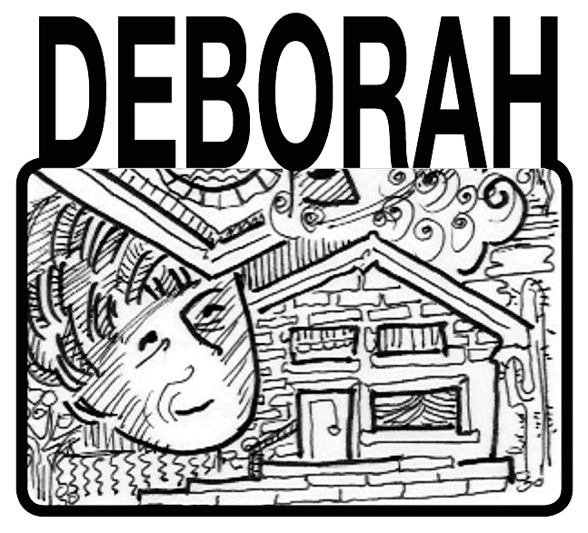The house I left behind like a worn down shell lies empty now. I emptied myself of it because it had become an empty nest. I don’t need my stuff to remind me of what I love or who I am. So, I left behind the yellow leather sofa and took only those pieces of furniture and objects that had value for me. Time to release the excessive drain on the uncertain income and my dire financial circumstances. I wanted to dump the mortgage, eliminate the debt and cut my stuff in half. As a result, I am lighter and more
free than before. The tall wooden secretary desk that belonged to my grandmother, my mother’s cedar lined hope chest, and a small rocker made with wood from the 1938 hurricane back east, are among the treasured items I kept.

It was time for me to “get out of dodge” only this time, Dodge meant moving out of 514 N. Dodge Blvd. where I had lived in solitude and sanctuary for 15 years. These transitions as we all know are not linear, but simultaneous, and this one started a long time ago when I took the risk of moving to Tucson from New England knowing not a soul. What I didn’t know was that a new kind of life as a POSSSLQ was preparing to unfold just 10 minutes away from my quiet home.

When I first moved to Tucson, the nest was full and I was filled by it. I filled it with my work as a consultant and leader of writing groups and I relished the ability to work at home. This empty nest was created not by kids leaving me, but a conscious choice to leave a familiar and safe place so something new could emerge.

The obvious choice for me, was to right size and cut my expenses, but in doing so there were other needs beginning to surface:
  - The need for more connection, intimacy, familiarity that comes from sharing a house and space with another.
  - A need to pay more attention to my creativity, that was too often blocked by worry and fear.
  - A need to express my new self that has been nurtured here - and allowed to practice self love and acceptance.

Once I put my condo on the market, the emerging needs continued to surface as I had time to ponder why it was taking so long to find a buyer. I knew what I wanted to leave behind, but what new did I want in my life? I realized I was leaving an empty nest and ready to re-nest myself with:

  - Freedom from economic worry.
  - Freedom to commit myself to someone in addition to me.
  - Freedom to be my creative self and share what I have learned.

The “miracle” of my securing a position as a live-in companion came along in mid-April, six months after I put my condo on the market. One of my angels here in Tucson, Mert, just “happened’ to stop by her neighbor’s home when Sharon was declaring her need for such a person to fill this position. She wasn’t feeling very hopeful. But Mert, fully aware of serendipity and magic, said “My friend Deb might be interested in something like that.” Free rent, shared housing, shop and prepare evening meals and be there...IN CASE OF AN EMERGENCY. If she falls in the middle of the night she wants someone there. Sharon is my age and was diagnosed with Parkinson’s Disease 13 years ago. But she is no slouch. Sharon Kha, former TV news reporter at KGUN and spokesperson for not one but three Presidents at the University of Arizona comprised her professional story. When Parkinson’s Disease forced her to retire from the University, she became a rapper, poking fun at Parkinson’s Disease, as El Dopa Diva. https://www.youtube.com/watch?v=78Wi-CVbwLA.

She had divided her house into two parts to easily accommodate two people maintaining independence and privacy. Each of us has a private bedroom and bath and sitting area, and we would share the living room and kitchen. It was easy to imagine myself there.

Being the risk-taker that I am I also possess a practical part of me and years of life experience. I lived “communally” for 2 - 3 years with 4 - 6 adults and know the good, the bad and the ugly of coordinating and creating healthy living arrangements. I have also lived alone most of my life. Relationships require boundaries. Sharing personal intimate space works best when the relationship is based on trust, respect, and a demonstrated ability to communicate wants, needs, and desires. Sharon and I cautiously and optimistically shared the requisite “getting to know you” conversations, but all the while each of us knew from the “get-go” that this partnership was made in heaven. All we had to do was our part in fulfilling it.

But if this were just a story about living quarters it would not be so miraculous. I was ready to serve, to commit to someone or something bigger than me. I had recently lost several dear close friends I hoped I would grow old with. I wanted and needed a new foundation for grounding myself in this next to final stage of my commitment to fulfilling my story here and now. But I first had to sell my condo!
Having never sold a house before I’m not sure what I expected but it certainly was not a seamless process. I had not anticipated the seemingly endless series of delays and rearranging of plans. The moving date was delayed at least 3 times. The first delay in moving was requested by the lender, who needed additional time for the buyer to secure the proper financing. Then there were the two people living with Sharon who recently married but still needed to find a home of their own. But in the end I didn’t have to move my stuff or me into temporary storage.

I can’t remember being so excited about my writing and my groups, once I knew my entire livelihood was not dependent on my success at marketing my work. I began to fantasize what will it be like to be rewarded and compensated for my being present. What kind of needs, demands, requests will be expected of me and will I be able to meet them willingly? And what do I need to feel rewarded, respected and recognized? This is not a time for me to remain silent in any way, shape or form. My presence is needed in order to make this work. And Sharon’s as well.

I know my guides are with me as I make this transition. I am not a caregiver - I am a companion to:
  - Enable her to continue her life work, being independent and creative,
  - Engage with her in activities we both enjoy such as writing, sharing friends, appreciating the quirky and unusual, our health and wellness challenges,
  - Be a friend, a companion to share our lives and a home we will co-create where we are safe and able to freely express ourselves and laugh a lot, and
  - Practice setting boundaries and self care; and being there for one another.
I want to be able to write and create synergy for successful aging (our book on serendipity and POSSSLQ). It’s all about the choices we actually have if we are gifted with knowing that. This is a wonderful time of my life. I am as solid as I’ve ever been. Grounded and grateful for this sanctuary and the solitude from the past and ready to share myself and my love in mutual companionship with Sharon in exchange for free living. Looks like a beautiful time.

The sky is a light red with clouds and a few patches of blue popping out here and there. I’m out on the back patio and the birds are going crazy with joy. The rightness of it all feels good to me. Mutual independence and some interdependency that feels so good. I’m allowing myself to feel the peace and to be the love that brought this change into my life. Peace that my financial woes are to be minimized if not eliminated. I like this shift from struggle and solitude into grace and companionship, empowerment and ease. The problems and challenges with scheduling all the moving parts came together. I know and trust the new path I am on, as I tried to trust the “not knowing.” Faith isn’t faith until it’s all you’re hanging on to.

Aging alone Shared housing Sharing resources

I like having someone to care about,
to hold in the light and keep in my prayers. I like feeling connected and needed.
I like the companionship, the sharing, the laughter.

POSSSLQ is the answer for now, for us That may change as time always does But for now, we are more than content.

WHAT A POSSSLQ IS FOR
This idea of sharing living quarters is hardly a new one. In centuries past households usually consisted of assortments of mothers, fathers, children, maybe a cook or a stable boy, grandparents, apprentices, boarders and other friends and
relatives who all lived together happily or not so happily. In more recent times many aging baby boomers remember when granny came to stay with them. They put a twin bed in one of the kid’s rooms or, if they were rolling in dough, built an addition to the house.

Now when granny can’t be left alone, it is more likely that she will
move into a facility called “Assisted Living.” But assisted living requires money, so both Deb and I expected that, for different reasons, we would have to get along on less and less. What neither of us expected was the spontaneous flowering of a rich and vibrant friendship that grew because we had cleared the way for change in our lives, and opened our lives structurally to support a new way of doing things. What we ended up with was that we were both better off financially and less isolated emotionally.

So, if you are wondering whether you should consider exploring the idea of becoming a POSSSLQ—Bravo! It’s not for everyone. If you consider this kind of shared housing seriously you’ll start thinking of what you have to offer, not what you have lost. At best, you may find that the end of life is the beginning of the richest, most profuse and nourishing time of all, filled with color and light. As Charles Osgood says,

“I’d be your friend and so much more. That’s what POSSSLQs are for”

QUALITY OF LIFE AS A POSSSLQ
I’m hearing a lot about quality of life these days, as everything in our society seems to be in transition. Are we better off today or yesterday? And what does the future hold? As we age
we become ever more aware that the quality of our life is of paramount importance. Starting with Maslow’s hierarchy, in the early years of our lives, we plot a course to meeting these five needs: Physical, Safety, Belonging, Esteem and Self Actualization. But my observation is that the aging process brings with it a certain decline in the importance of those needs relative to the “quality of my life.”

In addition, unexpected change brings with it additional stress on our constantly aging bodies. Being at any one of the stages listed above is fine, but there is something about going “down” the hierarchy that requires some mental adjustment. How many people are thrown down the ladder due to financial misfortune or unplanned medical mishaps?

Since I’ve been living with Sharon, who has advanced Parkinson’s Disease, I am becoming quite intimate with how the physical limitations can take precedence - in terms of basic safety and her physical abilities. But that is not at the expense of meeting the loftier needs. We are fortunate to have all of those needs being met with my moving in here.

Aging brings with it a host of changes regarding what one will tolerate before change will be undertaken. For me, I had to reach a financial threshold that had been staring me in the face for the previous two years. What finally made me wake up and realize I was working way too hard and stressing way too much to support the life style I had chosen, I have no idea. The fatigue finally wore me down and suddenly I realized I no longer needed to be a homeowner and that some other alternative might exist.

Renting or shared housing seemed to be two options. I presumed I would be a renter and continue to live a more simplified, sustainable life alone, as I had been doing for the past 15 years. But alas, the housing market here in Tucson for “affordable rentals” wasn’t what I thought it would be and the one single perfect place had not appeared.

Enter serendipity. Suddenly an opportunity I had vaguely considered was plopped down in my lap.
Certainly the possibility of being a “companion” to another women in need had occurred to me, but I had done little to draw that any closer. When it showed up, it was delightfully unexpected and continues to be so - six months after initially meeting. Little did I know then that meeting my physical and safety needs in this new and creative living situation would give a boost to the higher needs of the hierarchy. Our individual and collective creativity seems to be flourishing and our world has expanded as we meet each other’s friends in our extended community.

My quality of life has definitely been enhanced overall as a result of this major change. Undertaking change can of course be risky, but often it is worth taking the effort to be honest with yourself and ask the question: “Are you ready?”

WHAT MAKES IT WORK?

It has been six months. The effervescence of the early days has paled a little—we now go whole days without saying “I can’t
believe how well this is working out.” But replacing the excitement has been a deepening sense of trust and safety in
our life together.

We have yet to have a serious fight.
We’ve had a couple of disagreements
that could have turned into a fight if we had been more judgmental of one another. For example, Sharon likes
to invite people over for dinner spontaneously, not taking into account that I would have to cook the dinner!! So, when I came home one evening wanting nothing more than a glass of wine, only to learn that Sharon had invited a friend to dinner, I rose to the occasion with grace and acceptance, and prepared a delicious meal we shared together, including a “special” desert I just happened to pick up that day. But when the guest was gone, Sharon said “Were you upset I asked Mark for dinner?” and I replied “yes.” The conversation that followed covered the topics: being inclusive about decision-making, providing your POSSSLQ with a gracious “out,” and watching out for surprises. That kind of respectful communication over time - from intuition to expression - is part of their great success in getting along well.

The words, “responsibility” and “trust” are finding new meaning for Sharon and me. And the feelings of “vulnerability” and “intimacy” are surfacing in different ways. We both know that with a chronic disease in particular, a request for something as simple as putting compression socks on can mushroom into an time consuming set of responsibilities that could leave Sharon feeling vulnerable and me feeling overwhelmed.

Talking about our expectations has kept them realistic. A major factor in the success of this creative venture is that Sharon has a caregiver, Stacie, who comes in four hours a day, six days a week. It’s Stacie who helps Sharon shower and dress. It’s Stacie who makes doctors appointments and drives Sharon to the gym. It’s Stacie who says “I don’t like the color on your
face, Sharon. Let’s hook you up to the oxygen for a little while.” My role is to be a companion, not
a caregiver.

Getting a good, healthy, nutritious evening meal was one of Sharon’s top priorities. I, having lived alone, was used to eating out, grazing on salads and soups, or having wine, cheese and crackers for dinner. The first thing we discovered was we liked the same kinds of foods. This is a big one, for a successful shared living experience. Then I discovered that I was actually enjoying planning,

preparing, serving and even cleaning up when there was someone to appreciate it.
In the end, it’s about appreciation that makes sharing living quarters so meaningful. Such simple things… a shared meal, a question “how was your day?” and knowing you will get an honest response is of great value. Sharing living quarters is not an activity for those lacking courage, or those unwilling to speak their truth, but the benefits for those who are brave enough to try it
are spectacular!

TIPS FOR BECOMING A POSSSLQ

This works best if both sides have complimentary needs and resources. If one of you lives in a cramped apartment without even a balcony for potted plants and loves gardening, and the other has a huge yard and can’t keep up for health reasons, you should consider a POSSSLQ. Here are some tips to consider as you go through your own process. They are in no particular order except the way they came to my mind.

- Make a list of what you bring to the table and what you need from the other person. Mine boiled down to: I provide housing for no rent, they provide the evening meal.

- Draw up a simple memorandum that spells out what each side is responsible for. Other people would suggest that you get an attorney to draw up an agreement. It’s probably a good idea. We put a plain, everyday agreement down on paper.

- Check references. Do an online background check.

- Be flexible. This isn’t brain surgery; you can afford to try some new ideas.

- Set boundaries but make them few and state them clearly.

- When it comes to financial matters, keep things to yourself.

- Don’t share passwords or financial information.

- Get your affairs in order. Make a will, designate someone to have financial and medical power
of attorney and do advance directives.

- If you are sharing furniture, make a list of what belongs to whom so you won’t have petty little spats over it at a later time.

- Create an exit plan. How much notice does one give?

- Create “Transitions” savings account with enough to pay first and last month’s rent and other moving expenses. One of you will die before the other and you don’t want to be living month to month and have financial problems in addition to coping with grief.

- Exchange lists of people to be called in case of emergency.

  - Check to see what impact the home sharing could have on your finances—if you get food stamps, or social security. For example, the amount you saved in shared housing may be included in the total household income when they are deciding your eligibility for assistance.

  - Expect this to be more complicated than I make it seem

  - Consider the risk; consider the opportunity. And with any luck at all, you’ll find your POSSSLQ.

RESOURCES
SHARING HOUSING : Improve your life and finances - and make new friends
https://www.sharinghousing.com/

WOMEN LIVING IN COMMUNITY
http://www.womenlivingincommunity.com/resources/housemate-matching-networks/

National Shared Housing Resources http://nationalsharedhousing.org

MATCH UP AND SHARED LIVING RESOURCES
Golden Girls Network http://www.goldengirlsnetwork.org/

The Roommate Matching Site for Women 50 & Over roommates4boomers.com

ARTICLES OF INTEREST
A Housing Crisis for Seniors
https://www.nytimes.com/2017/01/28/opinion/sunday/a-housing-crisis-for-seniors.html?a ction=click&pgtype=Homepage&clickSource=story-heading&module=opinion-c-col-right- region&region=opinion-c-col-right-region&WT.nav=opinion-c-col-right-region&_r=0
“Not rich, not poor, and not ready for the cost of growing old” http://www.latimes.com/local/california/la-me-0104-lopez-getting-old-20170104-story.html?utm_ source=Today%27s+Headlines&utm_campaign=1bb977606e-

Community based models based on aging in place http://www.air.org/system/files/downloads/report/Community-Based-Models-for-Aging-in-Place- Nov-2016.pdf

The Hot New Millennial Housing Trend Is a Repeat of the Middle Ageshttps://www.theatlantic.com/
business/archive/2016/09/millennial-housing-communal-living-middle-ages/501467/

For more information, or to share ideas, contact us!
Sharon Kha 520 325 2485 sharonkha@aol.com

Deborah Knox 520 780 3834 dlkcoach@gmail.com www.lifeworktranstions.com

We have a lot of people to thank for the success of our POSSSLQ, both the life experience and the publication of this booklet. Beth Hunter and Mert Ingvolstad brought us together in person and Gwyn Roske’s inspired layout and design brought the publication together. Our deepest gratitude to all of you for your support.

